ECE 465 Lab 7
Introduction to Verilog
In this profession, you will be exposed to the Verilog coding language especially if your career interacts with Fully Programable Gate Array’s (FPGAs). Today this lab will focus on the coding language used to program combinational circuits.
Verilog:
The most fundamental identifier in Verlog is a module. In this lab, you will create multiple “modules” in order to get an understanding of the language. This will also be a review of previous labs. The way you’ll be modeling a circuit will be gate level modifying. Below, is example code (Figure 2) of the circuit in Figure 1.
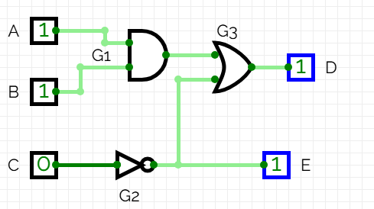
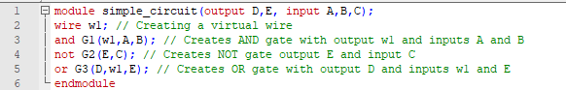
The code demonstrates modeling a circuit at the gate level. The parameters of the module, which is akin to a function in C, must describe the intentional inputs and outputs of your combinational circuit.

Problem 1.
Write Verilog code that describes the following circuit
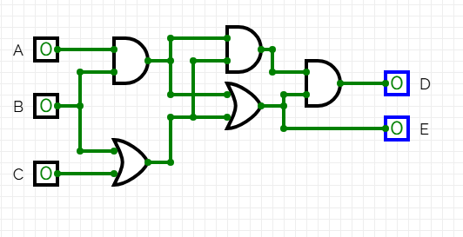
Problem 2.
In Verilog code, write a full adder.

In Verilog, you can write top-level modules that contain submodules. When declaring outputs you use the syntax output[n:0] X .. .
2b. In theory, how would you be able to construct a 4 bit full adder using modules?

2c. Using your answer from 2b, write Verilog code that represents a 4 bit adder

Problem 3.
In order to show an example of how the code works, you’re going to write your code into circuitverse.
- 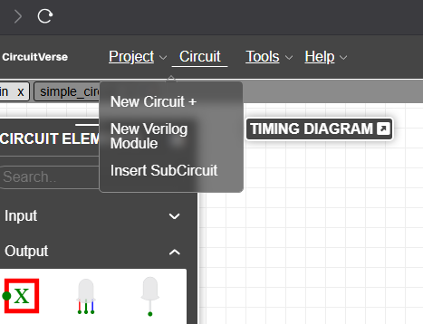
Select New Verilog Module and the following window will pop up.
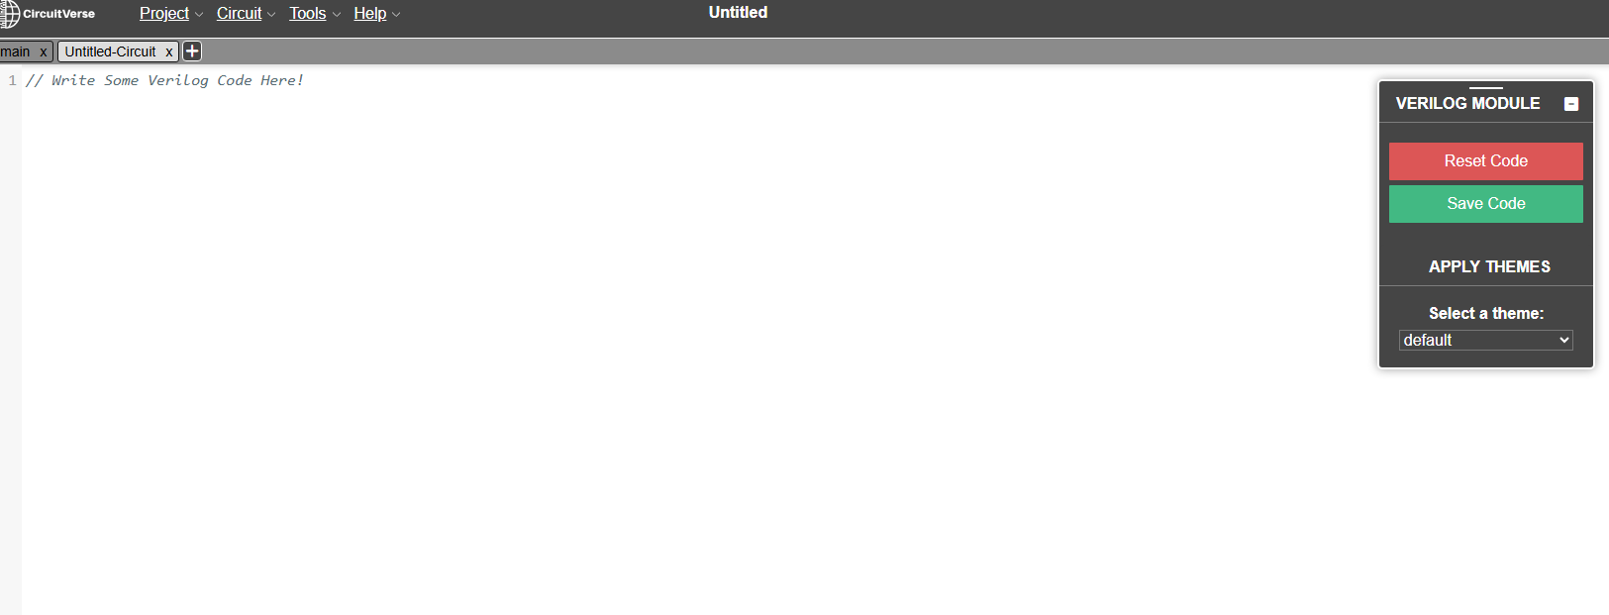
From the pervious question, implement your 4 bit adder.
- 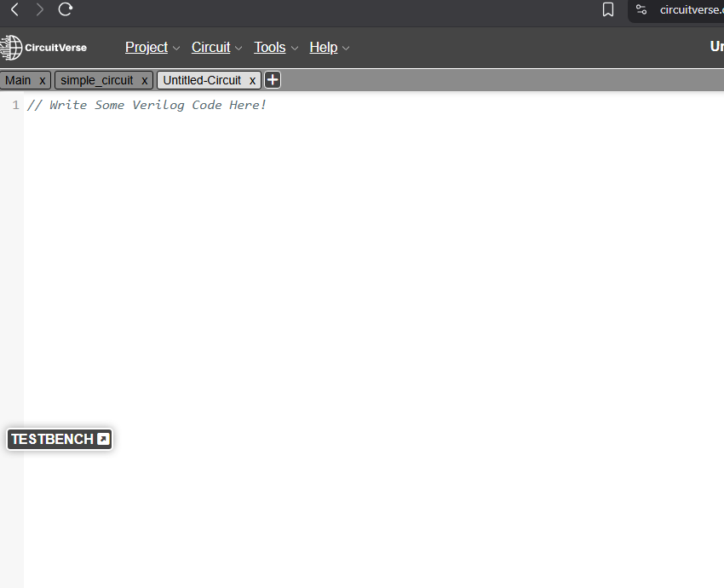
Write the Verilog code in the editor, and then save your code. You can now insert your circuit as a sub circuit.

